1. Resize (crop)
2. Angel Halo
3. Rotate
4. Blurred Image
5. Grayscale
6. Changed colors
7. Add Border
8. Resize

Original Image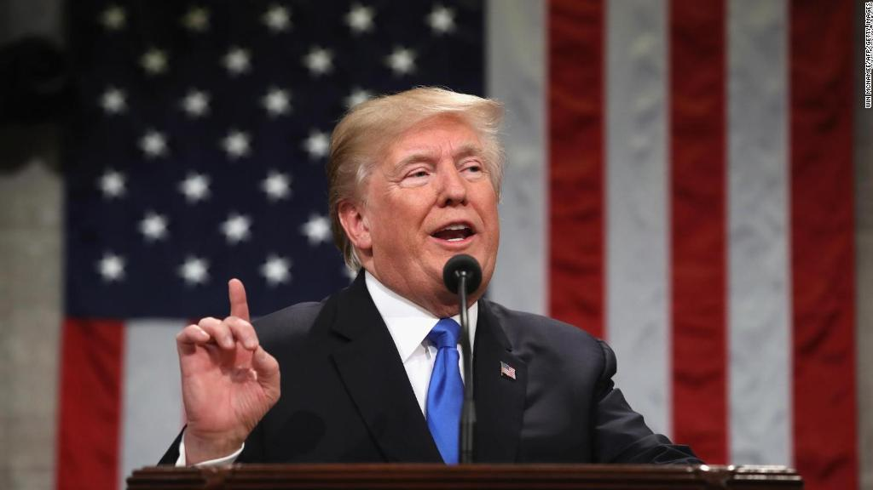

Change #1 Image Cropped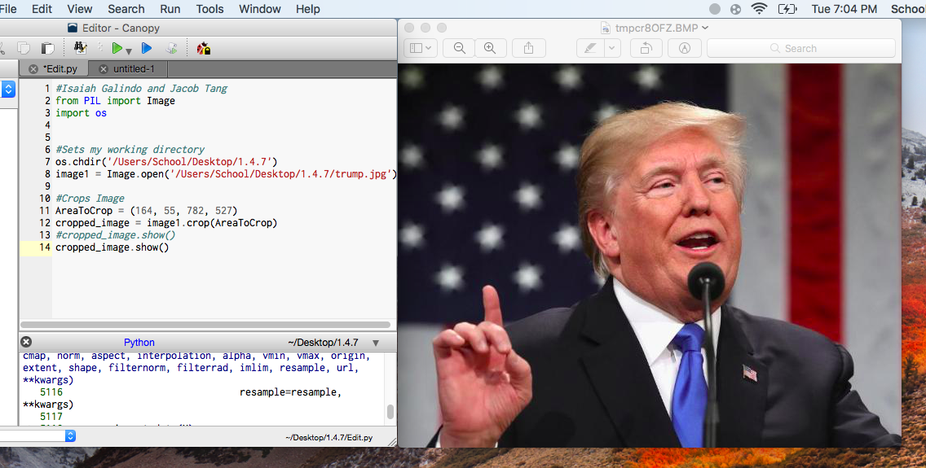

Change #2 We added an Angels Halo over Trump’s head

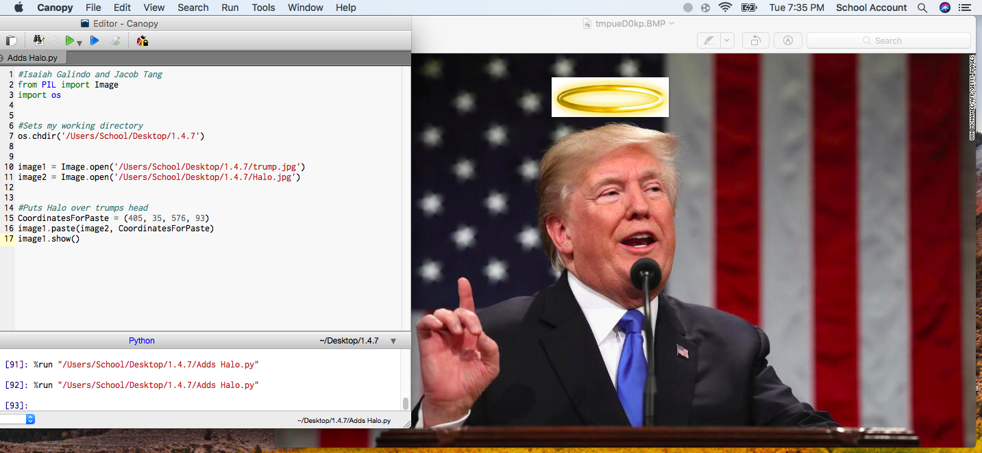

Change #3 We rotated the original image

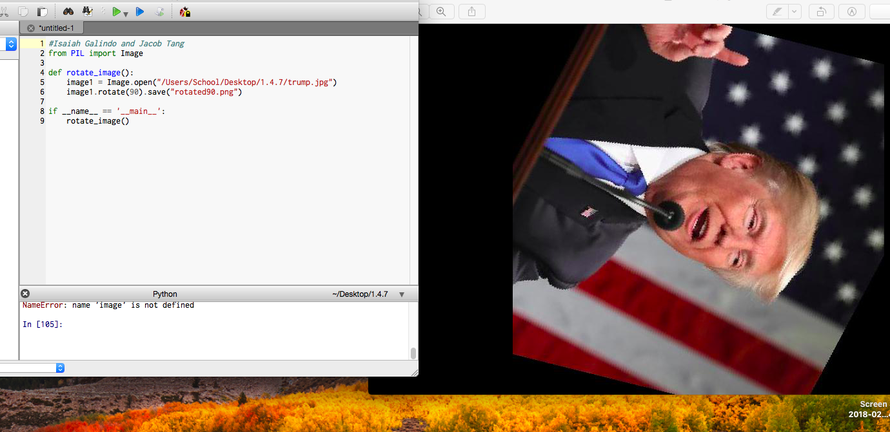

Change #4 We blurred the image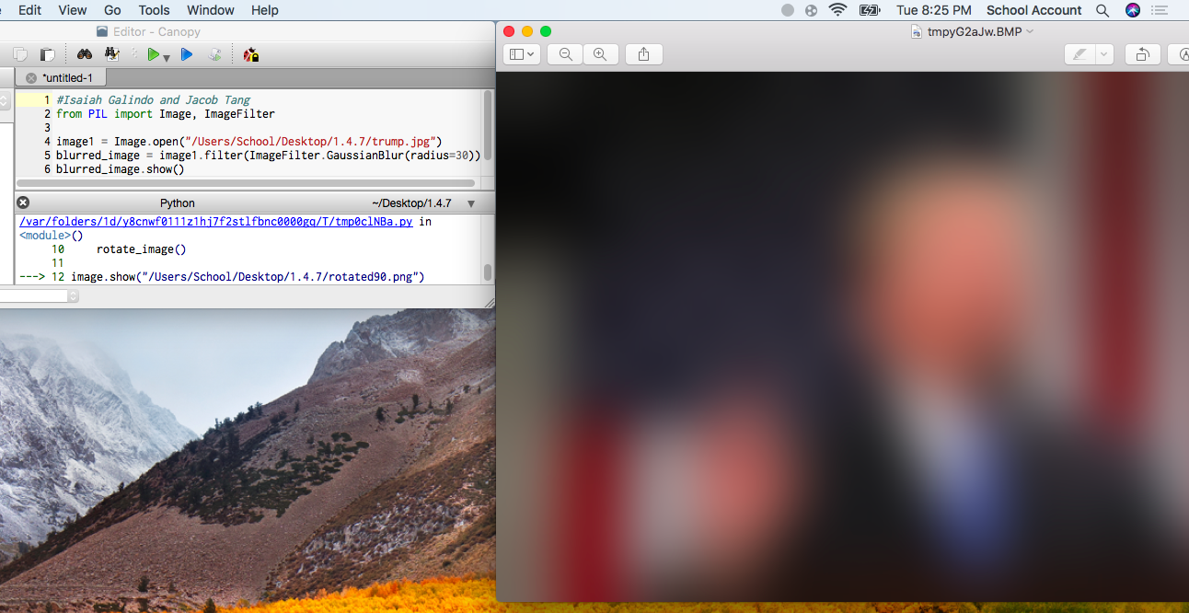

Change #5 We turned the image into a grayscale image

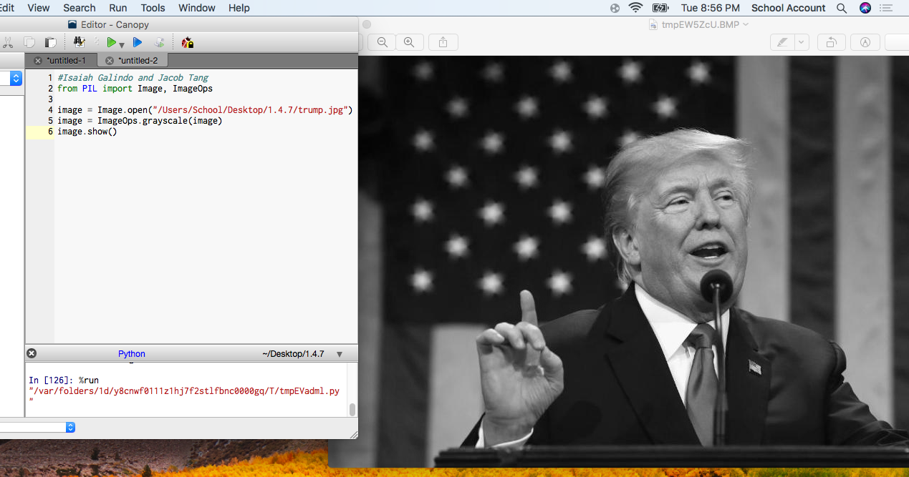

Change #6 We changed the color values of black and white to green and blue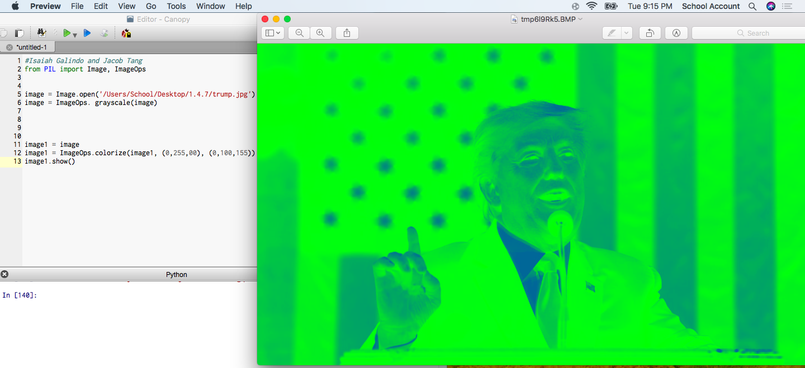

Change #7 We added a border to the image

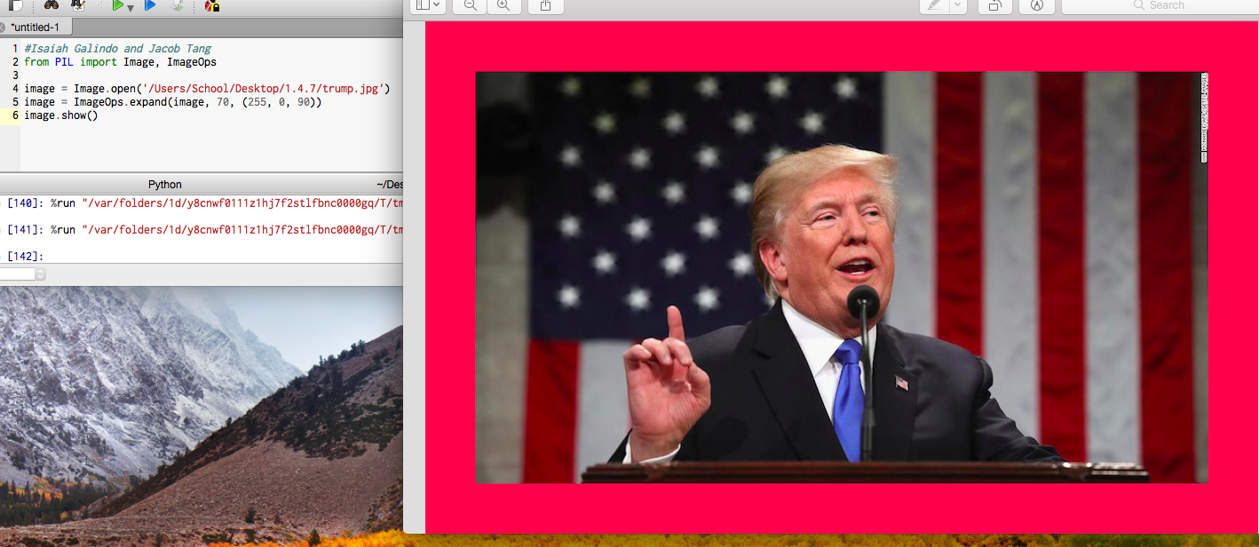

Change #8 We made the photo smaller

